Determining Age in the Skeleton

Objectives
- Describe ways to estimate age at time of death in subadults and adults.

Age Estimation (provide the definition)
Age estimation is the process of determining the age of a fossil or a person based on the biometric features.
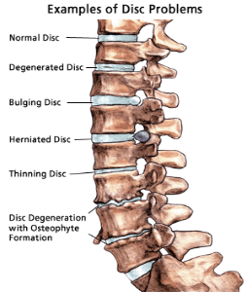
Age in Adults and Subadults
- Is it harder to estimate age in adults?
Estimating the age of adults is somewhat challenging. Middles age is not easy to estimate due to the transitions that happen based on hormonal and metabolic changes. The bones in the middle age are fully fused and this can be challenging the estimate the age.
- Are different periods of life easier to determine age than other periods of life?
  - In determining of people at different ages, the easier to determine is early childhood since the bones are still in the process of being formed.
  - Middle adulthood is hard to estimate due to progressive hormonal and metabolic changes.
- After age 25-30 the teeth are in and bones are fused. How can we estimate the age then? Measuring the length of bones and teeth is the best way of estimating the age of fused bones in the adults.

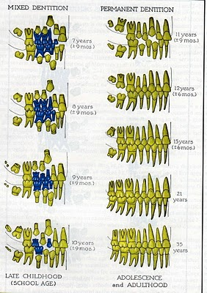
Subadult Age Estimation
- Tooth Eruption: Give an age range
  - At 2-6 years: all baby teeth (20) appear
  - 21- 24 years: permanent teeth (32) appear
- What is the dental formula for a subadult?
{I 2/2, C 1/1, P 2/2, M 0/0} x 2 = 20 teeth.
- How many are present of each?
  - 8 incisors
  - 4 canines
  - 8 premolars
  - 0 molars
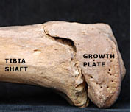
- Long bones: Give the definitions.
  - Diaphysis or shaft: long part of bone
  - Epiphysis ends of bones.
- What happened when long bones fuse? What does it mean? The fusion of long bones leads to formation of a stronger and long bone structure. Long bone fusion implies that growth is taking place at a faster and the person is developing.

Adult Age Estimation
- What is the dental formula for an adult?
  - {I 2/2, C 1/1, P 2/2, M 3/3} x 2=32
- How many are present of each?
  - 8 incisors
  - 4 canines
  - 8 premolars
  - 12 molars
- Tooth Wear, give one example:

Tooth wear is the loss of tooth substance by other substances except dental carries. For example, tooth wear can happen due to friction as a person bites the teeth together. Wear and tear happen as a person is a sleep.

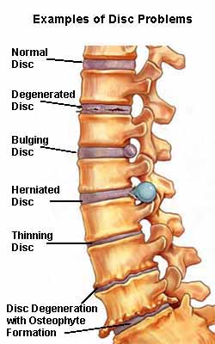
  - Following period of union of epiphyses; mid-20s and older, degenerative changes in many of the joint surfaces

Review
Describe ways to estimate age at time of death in subadults:  Describe ways to estimate age at time of death in adults: | Biological profiling values the age-at-death skeletal remains examinations as a critical method of estimating the age of subadults. The commonly used method is dentition analysis. In this system, the jaw measurements are used to determine the arch space and predict any malocclusion (Primeau, 2018). The skeletal examination is another method for estimating the age at death for subadults. The skeletal bones of a subadult are not completely fused.  The age at the time of death in adults can be through examining the skeleton. The surfaces of the cranium, pubic bones and rib ends tell much about the age of death for the adult (Primeau, 2018). The cranial sutures in the adult skull are much fused. Adult bones have experienced much wear and tear, which makes the rib ends for adults to have irregular projections. The bone resorption, deposition, and remodeling tell much about the estimated age of an adult.

Age in the Skeleton

- When an age estimation is given, what does it refer to?
Age estimations refers to determination of the age of a person using biometric features. Age estimation is much used by forensic anthropologists to tell the age of fossils (Aspray & Hill, 2019). The aspect of facial age estimation is based on the biometric traits extracted from an individual.

- Why is it harder to estimate an adults age compared to a subadult?
Estimating the age of adults is more challenging than that for subadults. Adults are not easy to estimate due to the transitions that happen based on hormonal and metabolic changes. The bones in middle age are fully fused, and this can be challenging the estimate the age. As for the age of subadults is easy to estimate since the bones and not completely fused, and skulls have large sutures (Calce et al., 2019).
- At what age are all teeth in and bones fused?
Between the age of 17 – 25 all the bones and teeth are fully fused.

- What is Diaphysis?
Diaphysis is the key shaft of a long bone made of cortical bone and bears bone marrow and fats rich tissues.

- What is Epiphyses?
Epiphyses refer to the end part of a long bone. The epiphyses grow separately from the diaphysis.

- What can be said after long bones fuse?
After the long bones fuse, there is no more lengthening of the bones.

- At what age is lipping pronounced?
Lipping happens progressively till the age of 30 years, after which the it increases and becomes more noticeable at the age of 50 years.

References
Calce, S. E., Kurki, H. K., Weston, D. A., & Gould, L. (2018). Effects of osteoarthritis on age‐at‐death estimates from the human pelvis. American journal of physical anthropology, 167(1), 3-19.

Primeau, C. (2018). Estimating Subadult Age: Diaphyseal Length. The Encyclopedia of Archaeological Sciences, 1-2.

Aspray, T. J., & Hill, T. R. (2019). Osteoporosis and the ageing skeleton. Biochemistry and Cell Biology of Ageing: Part II Clinical Science, 453-476.

